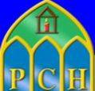
PCH STUDENT NEWSLETTER
|
March 23, 2020
Volume 1, Number 1

 | @PresHeadford | Staying in Touch in Difficult Times  To all our Students and their Families,  Thank you all for your fantastic co-operation on Thursday, March 12th as the school closed very suddenly following a directive by our government. It was so heartening to witness all the lovely interactions between students, staff and parents. Well done everyone!  As our new reality of safe-distancing, hand-washing and online teaching and learning settles in, please know that we in PCH, will continue to do our best for you. As students, parents and teachers settle into routines we shall all be learning together. As well as continuing to provide for your education, we shall focus on wellbeing, physical activity, positive mental health and coping strategies. We wish to take this opportunity to thank all those among our parent body who are helping on the frontline, be they in healthcare or other important services to the country. The Taoiseach in his address to the country asked that students be aware that this is a very stressful time for parents too. We ask that all of our PCH students show leadership, show responsibility, help with doing jobs, help at home and BE KIND.  We know many of you may be minding your younger brothers and sisters- this is very important work and you really are doing your bit to keep our country healthy. It may be stressful at times, but do your best to juggle your commitments at home with your school work. Remember, that as Presentation students and followers of Nano Nagle, we believe in “Deeds not Words”. We take action, we do things to help.  ‘Ar scáth a chéile a mhairimid - We all walk in each other’s shadow  Stay safe & well,  Aisling McAlpine; Principal, Ciarán Ryan; Deputy Principal & Orla Jackson; Deputy Principal
 | 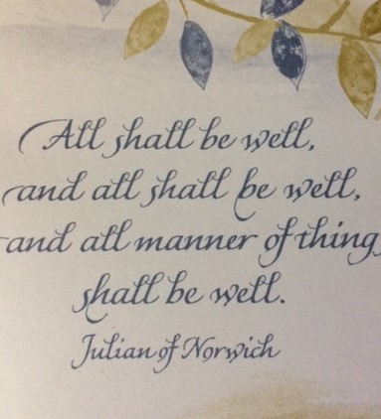
Presentation College Headford
www.presheadford.ie
 | PCH STUDENT NEWSLETTER
 | 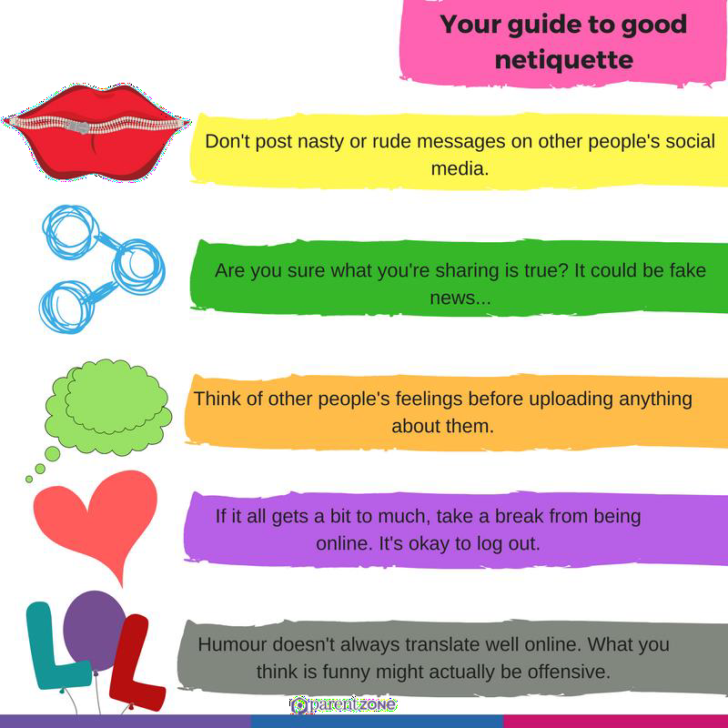  FAQ’s About Cancellation of Orals & Practicals  https://www.examinations.ie/misc-doc/BI-SE-67826275.pdf | Junior Certificate and Leaving Certificate Students  The Minister for Education Joe McHugh announced that the Oral & Practical exams scheduled for March 23rd to April 3rd were now cancelled. To ensure no student suffers as a result of this cancellation, the decision was taken to award 100% to all students in these exams. The closing dates for all course work & projects has now been moved to May 15th. It is anticipated that written exams will proceed as normal. Please continue to work towards your exams in June and follow the guidance of your teachers. Please follow this link for further details;  https://www.education.ie/en/Press-Events/Press-Releases/2020-press-releases/PR20-03-19.html  GSUITE ACCOUNTS AND LOGIN DETAILS  If you are experiencing any difficulty accessing your GSuite account, please contact Mr Ryder (tom.ryder@presheadford.ie) or Mr. Toner (john.toner@presheadford.ie) during school hours.  Career Guidance Department in PCH  Ms Whitney (joanne.whitney@presheadford.ie) and Mr Slattery (john.slattery@presheadford.ie) are available, during school hours, to answer any queries relating to Guidance/Careers/Subject choice.
