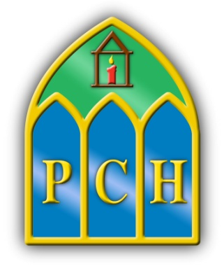 | Presentation College  Headford  Co.Galway  Tel: 093 35408  Fax: 093 35532  e-mail: office@presheadford.ie  Web: www.presheadford.ie
April 30th 2020

Dear Parents/Guardians,

Yesterday’s announcement by Minister Joe McHugh is welcomed by the learning community of Presentation College Headford, in the interest of our students' health and wellbeing. We did not wish to see students preparing for exams over the summer months without the support of their school community. Our wish is for families to celebrate the educational achievements of the students at this juncture while acknowledging their immense work ethic under incredibly challenging circumstances since enforced school closure on March 12th 2020.
We were hopeful for this announcement. We sought the opinions of all our parents on an array of issues related to student engagement through an online survey. The parents of 3rd Year expressed a clear desire for clarity on Junior Certificate exams and if possible, that any assessment be conducted during this school term. Students too, have expressed their strong wish to “have a summer” in their interactions with staff.
As a staff, in anticipation of this announcement but while awaiting official confirmation from the DES, we began consultation and planning last Tuesday. We have formulated what we consider to be a fair and equitable solution which protects the integrity of the assessment process and the wellbeing of our students and staff. We thank the students, parents and teachers for engaging in this process and the following is our offering which we believe will serve both student and teacher fairly, and well.
We propose to engage a specialist statistical modelling company who will take a student’s:
•Results from 1st Year Christmas and Summer examinations
•Results from 2nd Year Christmas and Summed examinations
•Results from 3rd Year Christmas and Mock examinations
And predict the most likely result a student would have received in the Junior Cert exam. This solution offers unbiased , accurate predicted grades for each student on each subject.
The predicted results are calculated using advanced statistical methods to estimate the most likely result a student would have achieved in the Junior Certificate based on all available in-house exams and mock exams.
We propose that the above would be weighted 70% of the student’s overall grade received. This is in keeping with DES and JMB guidelines offered yesterday which state that:
To ensure equity, greater weighting should be given to work that was completed by students in advance of the closure of schools on 12 March 2020.
Taking the above guidance into account, we further propose that:
The remaining 30% will be up to each teacher and department to award.
It could be broken up to reflect engagement since school closure and/or proposed assessment/coursework over the coming weeks and may include:
o Evidence available from assignments, tests, tasks journals, projects, practical and other work completed over the course of second year and third year
o Classroom-Based Assessments completed in second year and third year
o School-designed examinations, tasks, projects, assignments, essay style questions, presentations, or other tasks chosen by the teacher from the range of approaches agreed at school level.
Each department, in reflecting their decisions to students and parents, will publish a breakdown of their assessment criteria in due course.
School-based assessments will be devised and marked by the class teacher and will take cognisance of students’ accessibility to the mode chosen. The assessment format chosen will be accessible to ALL students in the class.
Equally, in preparing assessments, the method or form of assessments will be inclusive of students’ with special educational needs (SEN)and will provide differentiated approaches to allow students with SEN to access the appropriate assessment mode and be adaptable to their particular context.
We hope that assessments should be completed and marked before 29 May 2020 and a report issued to parents/guardians and students will issue as soon as is reasonably possible.

I ask you to continue to support your child's engagement with their online schoolwork and encourage them to embrace this changed assessment landscape. Our heartfelt desire is for our students to return to school safe, happy and healthy and wearing the ‘grey uniform’ as senior cycle students.
We wish you continued health in the coming weeks,
Stay well, stay safe and stay home (for now!),
Yours in education,

Aisling Mc Alpine Ciarán Ryan Orla Jackson
Acting Principal Deputy Principal Acting Deputy Principal

