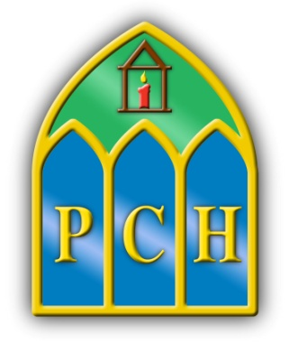 | Presentation College  Headford  Co.Galway  Tel: 093 35408  Fax: 093 35532  e-mail: office@presheadford.ie  Web: www.presheadford.ie

April 24th 2020
Dear Parent/Guardian and Student,
I hope you and your family have had a nice Easter break and that you are all keeping safe in these challenging times. We know from feedback from our students and interactions with our staff, that we are all missing the normality of school life as we adjust to new routines. We are very proud that so many students and our staff worked very hard before Easter to minimise disruption to learning.
There are still 5 weeks left in the school term and we will continue to connect with our students, engaging them in their learning. During this time, we will put an emphasis on finishing off remaining coursework, revision and preparation for end of term assessments. This is what we would usually do in these last few weeks. This applies to all students in all years. We would ask all parents to ensure that their children are engaging with their online learning and that they are doing the work assigned to them by their teachers in all subjects.
Engagement, participation and homework may form a percentage of students’ final marks this summer. As normal, students will be issued with a report this year. It is vital that students make an honest effort to engage in every subject and communicate regularly with their teachers for the remainder of the term. To better inform our work over the coming weeks we respectfully ask that all parents complete the following survey https://www.surveymonkey.com/r/F25HWTR on or before Wednesday, April 29th 2020
Specific information for Leaving Certificate and Junior Certificate students and their parents
As you are aware, from the media, there are significant changes to state exams this year. The Minister of Education, Department of Education officials and the State Examinations Commission have been engaged in an extensive consultation process with all educational partners, including student and parent representative bodies. The aim has been to develop clarity on all operational aspects of this year’s state examinations, while adhering to government health guidelines and the key principles of integrity and equity.
The Minister for Education confirmed yesterday that the Leaving Certificate will commence on July 29th 2020. We are advised that, pending public health advice, a more comprehensive timetable will be available at the beginning of June. We will continue to work with our students and our parents to ensure that your child gets the relevant correct information and support that they need. Our students will be thoroughly prepared for these exams.
In terms of assessment and reporting of this year’s Junior Cycle, the following clarifications have been issued by the Department of Education this week:
1. Students in recognised schools are required to study subject and short courses in accordance with the Junior Cycle Programme as set out in DES Circular 0055/2019
2. Students are not required to undertake Junior Cycle final examinations in 2020
3. Schools are free to use the assessments provided through the NCCA and SEC, but they are also free to design and organise the assessment of students’ progress in accordance with their own school’s policies
4. Examination fees in respect of this year’s Junior Cycle will not apply
However, in relation to the Junior Cycle examinations, Classroom-Based Assessments, Assessment Tasks and project work, the Minister of Education believes that it would be preferable that discussions with the education partners are concluded before schools consider their assessment arrangements for Junior Cycle students in 2020. This is very much aligned to our own position.
We assure you of the support of our School Leadership team, Year Heads, Guidance Counsellors, SEN team and individual teachers for all of our students now, and in the weeks ahead. One thing we have learned from the challenges posed by the last few weeks is that a school community is not bricks and mortar and it doesn’t depend on geography or proximity. Real community is built on the bonds that tie us together because of who we are, what we believe and what we dream of together. As always, please be assured that we are working as hard as we can to ensure continuity of quality education and systems of support for our students. Keep up to date by following us on Facebook and by visiting our school website www.presheadford.ie
Thank you for your continuing support,
Stay safe, stay well , stay home,

Aisling Mc Alpine Ciarán Ryan Orla Jackson
Acting Principal Deputy Principal Acting Deputy Principal

