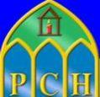
STUDENT

NEWSLETTER
|
May 27, 2020
Volume 1, Number 5

 | 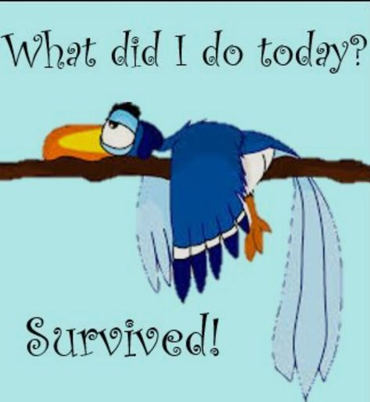 | TO ALL OUR WONDERFUL PCH STUDENTS AND THEIR FAMILIES  Well done to you all for completing eleven weeks in lockdown and eleven weeks of remote teaching and learning!  The end of the school year is nearly upon us. It probably feels quite strange for you, you are not getting to celebrate that ‘last day of school’ feeling with your friends and we know this must be very difficult for you all. Our Leaving Certificate class of 2020, who have missed out on the rite of passage that is finishing secondary school, are very much in our thoughts and prayers. We are all really looking forward to seeing our Leaving Certs of 2020, early in the new school year, for their postponed graduation ceremony  We also look forward to a celebrating an online Mass of thanksgiving with our whole school community on Thursday, June 4th (further details will be sent to you all next week). It is important that we take time to pause, reflect, and give thanks as a school family. We have been through a very anxious time and thankfully, we are all still here to tell the tale.  Congratulations and well done to you for engaging so well with remote teaching and learning. It was not easy and we know you missed the fun and ‘banter’ of school. Your teachers deserve a big ‘bualadh bos’ for providing you with the best possible continuity of education, given the extenuating circumstances.  Please keep safe and follow the government guidelines over the summer. If we all play our part, we will get back to ‘normal’ sooner rather than later.  Have a lovely summer, enjoy the sunshine,  Tabhair aire  Aisling McAlpine, Ciarán Ryan & Orla Jackson

01 Letter

02.End of Year

03.Calculated Grades- Guides
 | Never apologise for having high standards. People who really want to be in your life will rise up to meet them.
 | 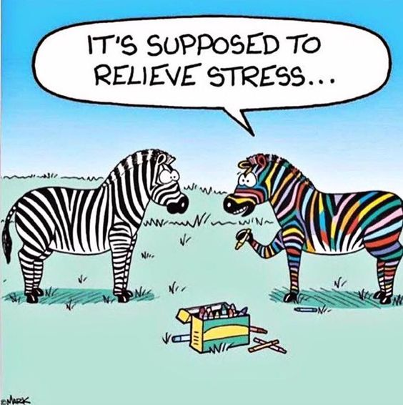 | LOCKERS  As soon as it is safe to do so we will contact you about retrieving the contents of your lockers.  BOOKLISTS  Booklists will be published on the website in mid-June, you will be notified of this by text  REPORTS  End of year reports will be issued through VSWARE over the coming weeks. You will be notified by text.  TEXTBOOKS ONLINE  Remember that many textbooks are available to download for free on websites such as www.folensonline.ie or www.edco.ie. Please avail of this wonderful opportunity before they expire in the next week or 2!  SUPPORT PHONE LINES  This time of isolation can be difficult for everyone. If you feel you need support, at any time, please reach out to one of the organisations below:  Pieta House - 1800 247247 or TEXT HELP to 51444  Jigsaw - for parents and students alike - 1800 544729  Samaritans - Freephone 116123  Teenline - 1800 833634  Leaving Certificate 2020: Useful Guides  A Guide to Calculated Grades for Leaving Certificate Students 2020  https://www.education.ie/en/Learners/Information/State-Examinations/a-guide-to-  calculated-grades-for-leaving-certificate-students-2020.pdf  Leaving Certificate 2020: Information & Resources (includes a series of questions / answers)  https://www.gov.ie/en/publication/2f07eb-leaving-cert-2020-information/  Advice from NEPS re Health and Wellbeing of Leaving Certificate Students  https://www.education.ie/en/Learners/Information/State-Examinations/wellbeing-mental-health-young-people-leaving-  cert-covid-19.pdf

