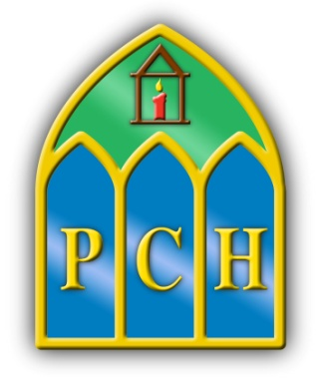 | Presentation College  Headford  Co.Galway  Tel: 093 35408  Fax: 093 35532  e-mail: office@presheadford.ie  Web: www.presheadford.ie
May 11th 2020
Dear Leaving Certificate Parent (s) / Guardian (s),

There is no doubt that the uncertainty dominating the last few weeks must have caused huge stress and worry in your household. In this light, the decision by the Minister of Education to cancel the Leaving Certificate exam and replace it with calculated grades is to be welcomed.

I realise that this may not be the solution that some of you may have desired, however, these are unprecedented times and therefore require unprecedented solutions.

Naturally, for many, there is disappointment, not only at the fact that the students did not get to complete the written exam but also that your child’s years in PCH have ended so abruptly. For the students, now, no more class, no more books, no more folders, no more ‘laps’, no more meeting up with their friends in the school environment. Indeed, unusual times. We are arranging a ‘Virtual’ Graduation Mass for our Leaving Certificate students shortly, please watch our Facebook, Twitter and Website accounts for further details. We also hope to hold a certification and awards ceremony in the Autumn, so that we may say goodbye to the class of 2020 in person.

We must trust the process now, and as outlined in the attached document;

‘Teachers know their students and can balance a variety of factors in arriving at a balanced judgement in relation to their students’ expected performance. Their professional code of practice, underpinned by the values of Integrity, Trust, Care and Respect is core to how they work in schools to ensure the best outcome for their students’.

I am sure you still have questions and are unsure of the days ahead but please, rest assured, that, as we have clarification around some issues not addressed in the attached document, we will be in touch. Please do not be offended if we do not respond to communication regarding individual grades.In the interest of maintaining the integrity of the process, the Department of Education & Skills has advised us to refrain from engaging in any communication which may be detrimental to this process.

We hope that you will continue to trust in the process and know that PCH staff will do everything they can to support you and your child through these times. Thank you for your valued support down through the years not least these past few challenging weeks.

Please take time to read the attached document, if you have not already seen it. I hope it will provide clarity around some of your many questions.

We will be in touch again soon,

Stay safe and stay well,

Aisling Mc Alpine Ciarán Ryan Orla Jackson
Acting Principal Deputy Principal Acting Deputy Principal

A Guide to Calculated Grades for Leaving Certificate students 2020

