STUDENT

NEWSLETTER
|
May 15, 2020
Volume 1, Number 5

TO ALL OUR STUDENTS AND THEIR FAMILIES
What an historic and unforgettable week in Irish education. This is the first time since 1926 the Leaving Certificate has been postponed. You truly are a year to remember, the Leaving Cert Class of 2020. But we know you are a class to remember for many reasons other than just being the year the Leaving Cert was cancelled. You are a wonderfully talented and caring group of young women and men. It was an absolute privilege to journey with you throughout your years in PCH. I think of you daily as I light candle in the window and the quote that keeps coming to mind is ‘Hope anchors the Soul’ (Hebrews 6:19).
The Minister for Education announced that the Leaving Cert will be replaced with a system of calculated grades. We are still awaiting clarification and guidelines as to how this is going to work. I attach links, on the next page, to all the available information we have to date.
We would like to pay a huge tribute to our Leaving Cert class of 2020, their teachers, their parents and their extended families for their remarkable resilience, stoicism, fortitude and commitment during such a time of anxiety, stress, doubt and uncertainty.
We all know in PCH that education is not just about curricula and syllabi; it is about life, love, laughter, growth, friendship, challenges and being the best, you can be, in all spheres of life. We are so proud of the way all of our community has adapted, engaged, grown and developed to adjust to the rigours of our new reality.
As we approach the final weeks of the academic term, we encourage all of our students from 1st to 5th year to continue to put their best effort into their work. It has been lovely to see you during our ‘live’ Assemblies. We look forward to further assemblies with our senior students in the near future.
I know we all face uncertainties about next year, but as you know that is all to be worked out yet. Please be assured that you can trust us in PCH to communicate with you as soon as we are informed of any developments.
Tabhair Aire
Aisling McAlpine, Ciarán Ryan & Orla Jackson

Keep These Things

For A Newsletter

01 Letter

02&03. Useful Information

04.Cyberbullying- How to Deal With it
 | “No man is an island, entire of itself; every man is a piece of the continent, a part of the main. If a clod be washed away by the sea, Europe is the less, as well as if a promontory were, as well as if a manor of thy friend's or of thine own were: any man's death diminishes me, because I am involved in mankind, and therefore never send to know for whom the bells tolls; it tolls for thee.’ John Donne
 | 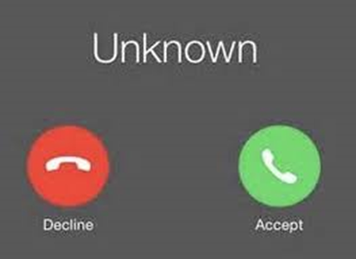  You may notice an unknown number on your phone over the next few weeks- we know you may be uneasy about such numbers but it could be us checking in to see how you are doing or responding to a request.  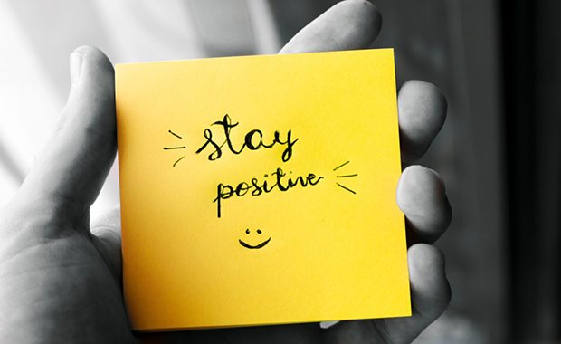 | Links to Leaving Certificate Calculated Grades Information;  https://www.education.ie/en/Press-Events/Press-Releases/2020-press-releases/PR20-05-13.html  https://www.gov.ie/en/publication/2f07eb-leaving-cert-2020-information/#information-for-leaving-cert-students  https://www.gov.ie/en/publication/1afce4-a-guide-to-calculated-grades-for-leaving-certificate-students-2020/  SUPPORT PHONE LINES  This time of isolation can be difficult for everyone. If you feel you need support, please reach out to one of the organisations below:  Pieta House - 1800 247247 or  TEXT HELP to 51444  Jigsaw - for parents and students alike - 1800 544729  Samaritans - Freephone 116123  Teenline - 1800 833634 | FA

In our online survey some parents noted that they had difficulty navigating Google classroom
Please find below a link to an online guide to Google Classroom for parents.
http://presheadford.ie/wp-content/uploads/2020/04/2020-Parents-Guide-to-Google-Classroom.pdf
USEFUL EMAIL ADDRESSES:
YEAR HEADS
1ST YEAR- MS SUSAN CURRAN; susan.curran@presheadford
2nd YEAR- MS ANITA MCGONAGLE; anita.mcgonagle@preheadford.ie
3rd YEAR- MS SARAH WITHERO; sarah.withero@presheadford.ie
TY/5thYEAR/LCA1- MR BRENDAN O’MAHONEY- brendan.mahoney@presheadford.ie
LEAVING CERT/LCA2-MR SEÁN CONLON; sean.conlon@presheadford.ie
SCHOOL OFFICE
office@presheadford.ie
CAREER GUIDANCE COUNSELLORS
MS JOANNE WHITNEY; joanne.whitney@presheadford.ie
MR JOHN SLATTERY; john.slattery@presheadford.ie
TECHNICAL ISSUES
MR TOM RYDER; tom.ryder@presheadford.ie
MR JOHN TONER; john.toner@presheadford.ie
PLEASE COMMUNICATE DURING SCHOOL HOURS ONLY

CYBERBULLYING
Cyberbullying is a new form of bullying. This form of bullying happens a lot on social media, online forums, text and email.
Examples of cyberbullying include:
- abusive messages or slagging on Facebook, Twitter, Snapchat and Instagram
- offensive comments on videos or posts
- spreading rumours online
- hacking into your online accounts
- posting offensive images
Cyberbullying can happen to anyone. People are able to create fake or anonymous profiles and hurtful comments. These people would usually not say these things in real life. You can also be bullied by someone you know.
Online bullying is serious and many new laws have been introduced to protect people.

How to avoid cyberbullying

Never give out your passwords
Always keep your passwords and PIN numbers to yourself. If you use a public computer, log out of your email and social media accounts. Use good passwords for your phone.

Pick your social friends carefully
Whatever you post online can be seen by everyone who has access to your page or the discussion board. Make sure you are okay with sharing the information. Even if you have a private account, anything you post is considered public.

Use netiquette
Be polite to other people online. Think about what you're saying and whether it might be hurtful or embarrass them in public, even if it's funny.

Don't send a message when you are angry
Wait until you have calmed down and had time to think.

Remember: The internet doesn't forget
Posts and messages can never be permanently deleted. Snapchat offers temporary posts. These posts can easily be screen-grabbed.

How to deal with cyberbullying

Don't reply
Even though you might really want to, don't rise to the bait and reply to messages from someone who's bullying you. They want to know that they've got you worried and upset. Chances are if you never reply they'll get bored and leave you alone.

Report or block someone
You can block people from phoning or sending texts. You can also report them. Find out how to report or block people in the help section or frequently asked questions section (FAQ) of a website or app.

Go offline
If you feel like social media is becoming too much, switch off. Consider your time spent on social media and whether you need to keep your account.

Inform your phone company or Internet Service Provider (ISP)
They can block texts, calls or online messages from specific people.

Change your contact details
Get a new username, a new email address, a new mobile number and only give them to your closest friends.

Tell someone
If it's bothering you, don't keep it to yourself. Talk to someone about it.

Inform the Gardaí
If the messages are ever threatening or it's getting serious, tell the Gardaí. It's against the law to threaten people, and the Gardaí can put a stop to it. They are there to keep you safe, and they generally want to know about stuff like this.

Keep a record
You don't have to read the messages, but keep them and keep a record of the time and date. This can act as evidence if you ever need it. It can also help the Gardaí or your ISP find out where the messages are coming from.

Go offline
If you feel like social media is becoming too much, switch off. Consider your time spent on social media and whether you need to keep your account.

Inform your phone company or Internet Service Provider (ISP)
They can block texts, calls or online messages from specific people.

Change your contact details
Get a new username, a new email address, a new mobile number and only give them to your closest friends.

Tell someone
If it's bothering you, don't keep it to yourself. Talk to someone about it.

Inform the Gardaí
If the messages are ever threatening or it's getting serious, tell the Gardaí. It's against the law to threaten people, and the Gardaí can put a stop to it. They are there to keep you safe, and they generally want to know about stuff like this.

Keep a record
You don't have to read the messages, but keep them and keep a record of the time and date. This can act as evidence if you ever need it. It can also help the Gardaí or your ISP find out where the messages are coming from.
