1st Year 2021/22
Stationery List/Items not included on BOOK RENTAL SCHEME

Below is an outline of the general equipment/stationery, outside the Book Rental Scheme, your son/daughter will need for first year. Please note this is just a guide list and additional items outside this list may be required during the school year.
Please ensure your son/daughter’s name is on every item of stationery and uniform. The school cannot accept responsibility for items lost or stolen.

- All books will be covered, issued, and distributed to incoming 1st Year students 2021 during their first week in PCH.
- All core textbooks will be provided for in full under the scheme
- Workbooks will not be provided for under the scheme. Students will be informed of these workbooks and their cost during the first week of school.
- All textbooks remain the property of the school and must be returned by the student at the end of each academic year. There will be a cost incurred for lost/damaged textbooks.

Generously sized pencil case containing:

- Blue/black & red pens/biros - buy in bulk and have at least two in your pencil case at a time
- Pencils - buy in bulk and have at least two in your pencil case at a time
- Pencil sharpener
- Eraser/rubber
- Highlighters - ideally 4 different colours
- Small ruler/larger foldable ruler (less likely to snap)
- Colouring pencils

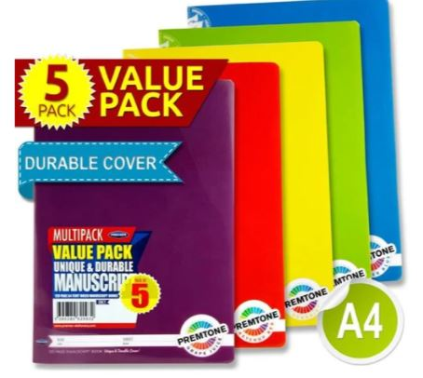
General stationery supplies:
(Teachers will give you more information on specific stationery required once you get started in PCH)

- 5x 88 page copies

- A4 Manuscript Books (durable soft plastic cover)

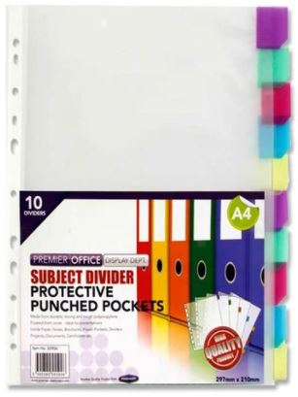
- A4 subject dividers

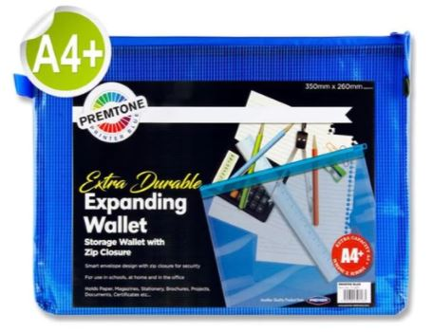

- A4+ mesh zip heavy duty folders/wallets (large enough to hold subject books) - one for each subject’s books/resources - different colours please. (These are necessary to protect rental books & help students get and stay organised)

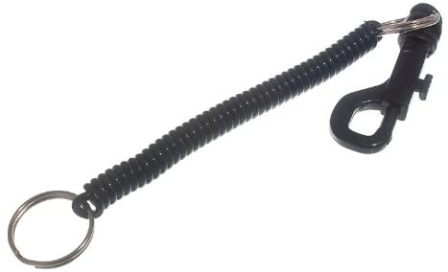

- Spiral extendable keyring for locker key
Maths:

- Mathematical Construction Set
- A4 squared refill pad
- A4 Ring Binder Folder (zipped)
- Casio Calculator
- Maths Tables

Geography:

- “Geopack” - supplied by Potluck Headford

English/Irish/Modern Foreign Languages:

- English Dictionary
- Irish Dictionary
- Dictionary for foreign language - German/Spanish/French
(Pocket dictionaries sufficient and students may already have English & Irish from National School).

Business (if you have chosen to study Business)
- 1 x A4 Hard back copy
- 1x A4 Soft copy
- 1 A3 Zipped folder

Applied Technology ( If you have chosen to study Applied Technology)
- No book required, €30 Material fee to be paid in Sept. to the school

*This list was correct at time of going to print

