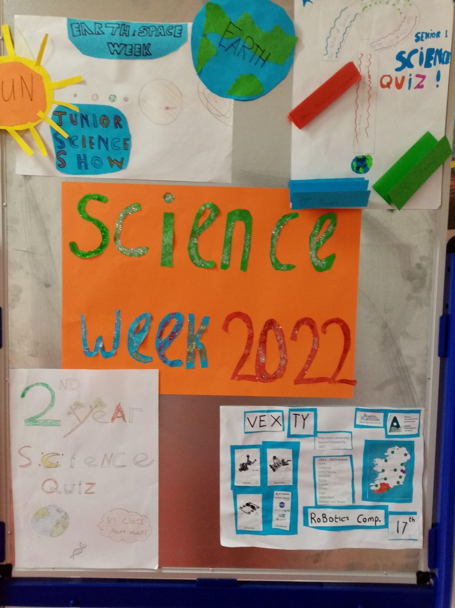

A number of events took place last week to mark Science week 2022. Our first years were given the task of designing a poster on any science topic that they were interested in. We have had a fantastic response and we are in the process of selecting winners from each class group and an overall winner.

Our second years took place in table quizzes on Thursday and Friday and competition was fierce and all students enjoyed the event.

Some of our TY students and fifth year physics students travelled to ATU on Thursday to take part in Robot trails as part of the VEX Robotics competition. Many thanks to ATU for hosting the event and Boston Scientific who had a robotics display on show allowing our students to experience robotics in the medical device industry. A very enjoyable day out was had by all.

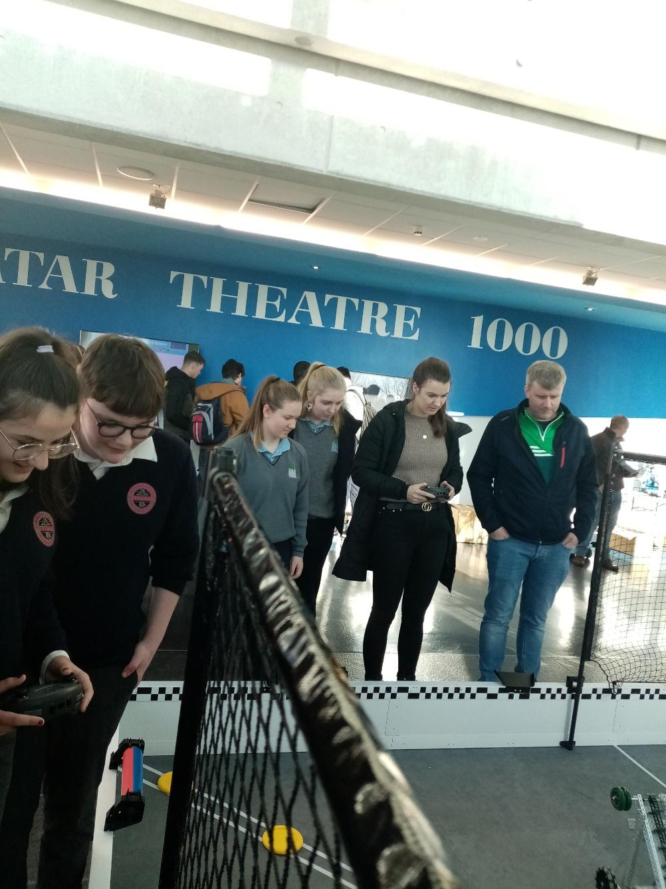

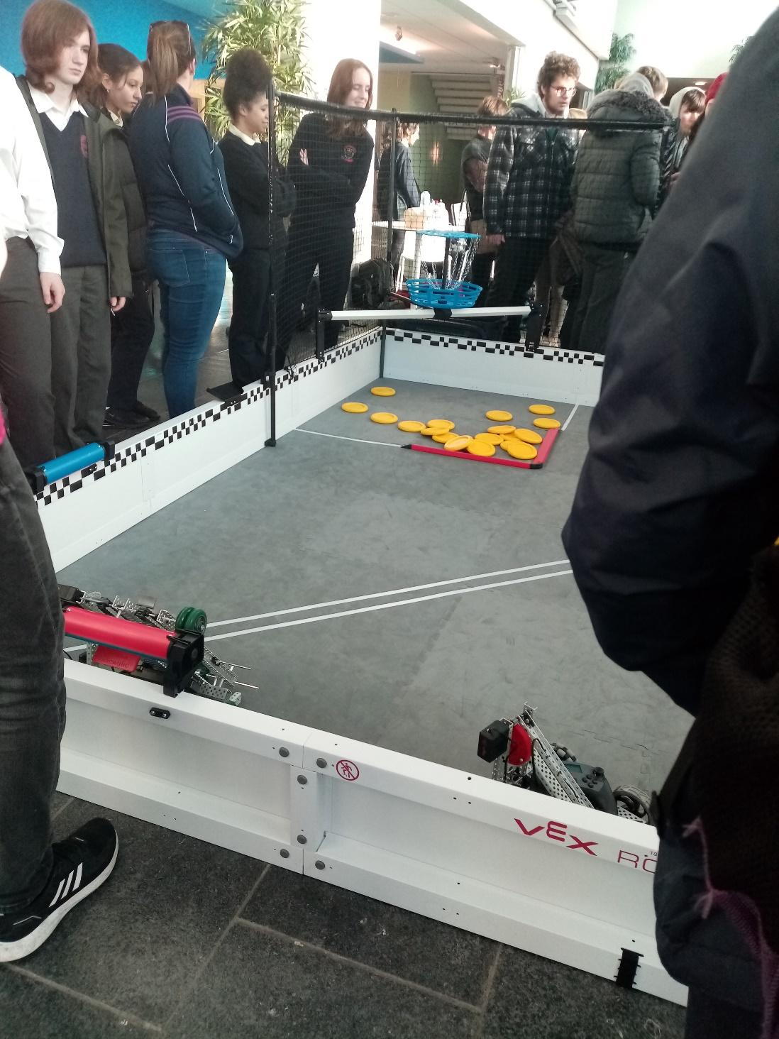

Later that evening 9 of our senior science students travelled to ATU for the ISTA (Irish Science Teachers Association) Senior Science Quiz which returned after a break due to Covid. Again, a great evening was had by all and we all returned home with more knowledge than we had prior to the event. Pictured are Lucy Mullin, Saibh Malcolm, James Moran, Lisa Greaney, Lauren Price, Anna Cooper, Caoimhe Lynch, Matthew Martyn and Elizabeth Busari.

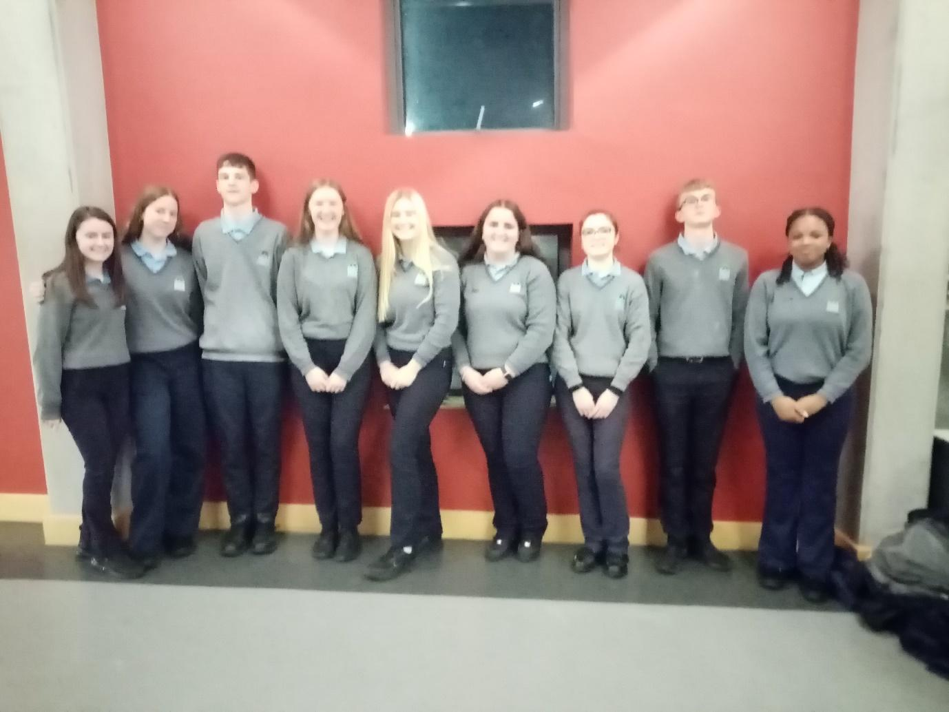

On Wednesday 16th November we welcomed Melissa White, Gurteen College, Co. Tipperary, to speak to our 5th Year Ag Science students. This was a very engaging presentation where she explained to students all about Gurteen College, their options of courses there and the practical aspects in relation to residential accommodation onsite & costs involved in studying at Gurteen College. She went into the detail of the various enterprises in Gurteen - from sheep, beef, tillage, biomass, machinery & dairy. Students enjoyed the practical demonstration of general items used on farms and the afternoon was concluded with a competition for our students. We are awaiting to hear who the lucky winner of an O’Neills jacket will be. Before leaving PCH, Melissa invited our students to Gurteen College next Spring for a tour of the college. We are already looking forward to it.

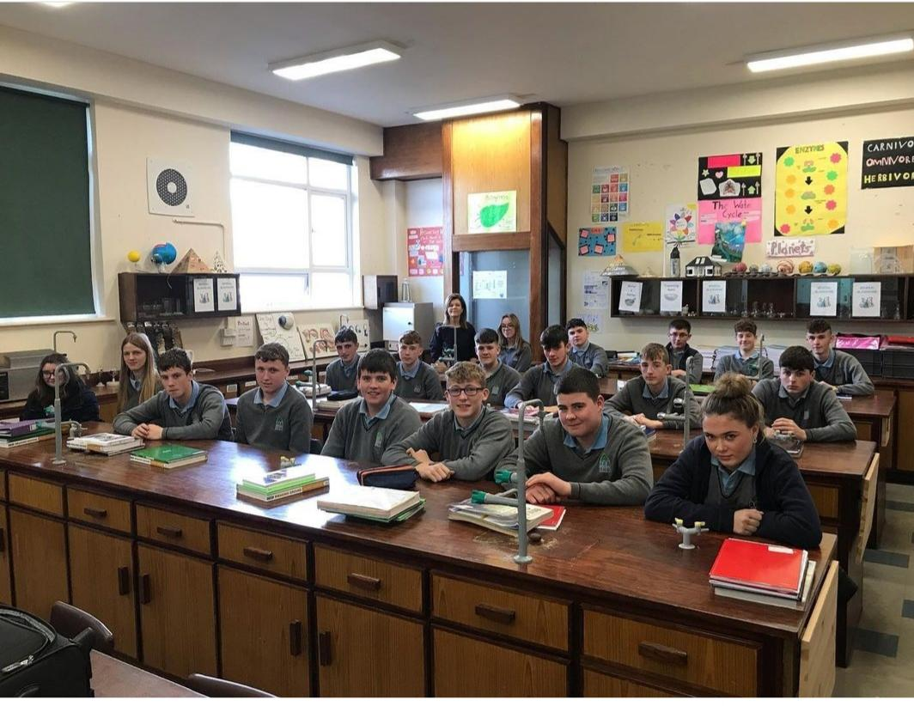

As we look to the night sky we imagine what lies beyond our protective blanket of the atmosphere. We sometimes glimpse visitors from beyond as shooting stars as they burn up in the atmosphere above. We may witness the night sky light up in a cosmic dance with the beautiful Northern Lights. There is even the possibility to gaze upon ancient distant travelers as comets as they pass by us on their own journey around our star, The Sun. Through telescopes we gaze out into the universe and travel through space and time. Our scientific endeavours and exploration of space through robotic spacecraft have uncovered incredible vistas and secrets yet to be explained.

Thursday 17th November we welcomed David Feronfrom Northern Ireland’s Space Office. Students from 1st Year up to LCert who had science on the day were invited to David's presentation.

This presentation took our students on a journey through space and time and highlighted some of the amazing discoveries we have made about our own Solar System and out into interstellar space and the universe beyond.

We were also very fortunate to have Peter Woulfe, past pupil of PCH & Chief Medical Physicist Galway Clinic, in to speak to 5th Year Biology students about STEM and about both his work & research in STEM. He spoke to our students about all the opportunities STEM has to offer them in their future careers. He went through a typical day working in the Galway Clinic. Finally he spoke to us about his PhD research in conjunction with University Limerick - this research aims to minimise the side effects of radiation in the treatment of prostate cancer.

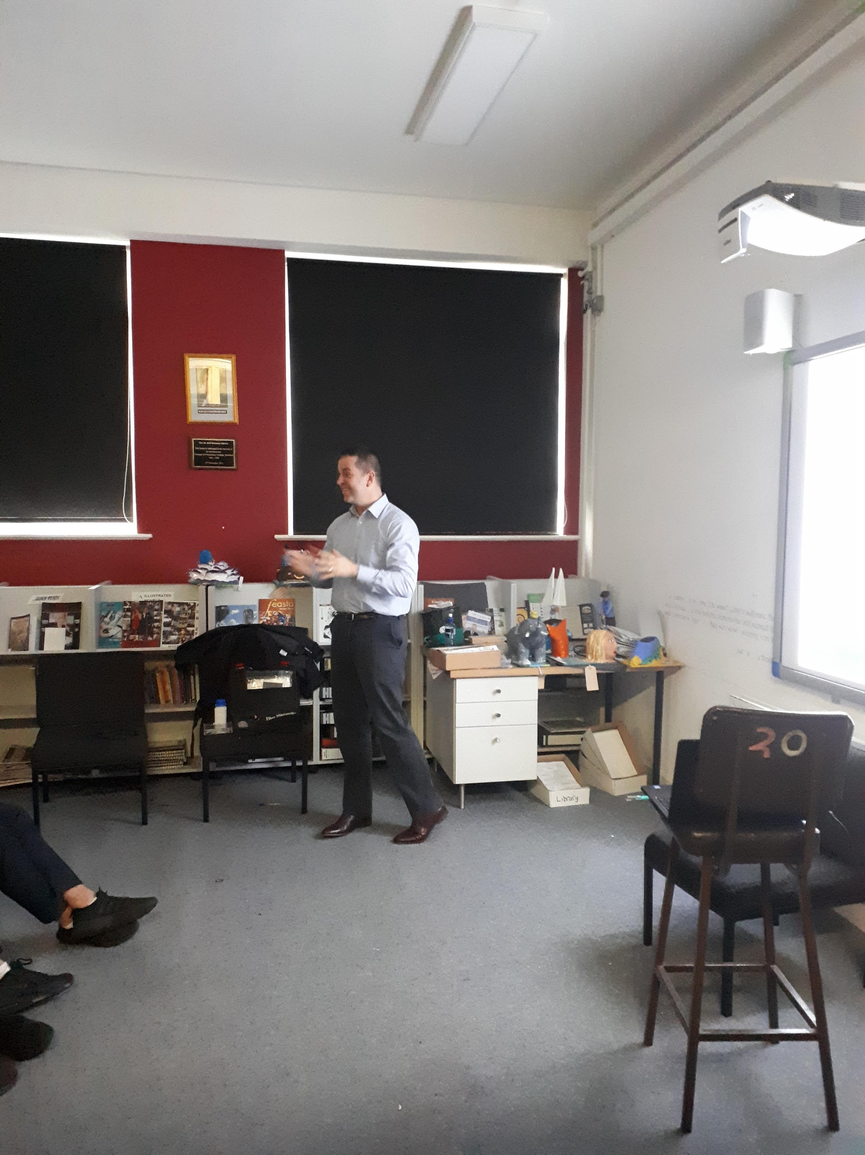

<https://www.nature.com/articles/s41598-021-90880-6.epdf?sharing_token=roGIGqoN4r_dMcXnW1oJrNRgN0jAjWel9jnR3ZoTv0OGxm7Zr8bKYSiHGcsYRUP5mbanWgJvV3Fs9RdRfgnbi_UbMnZs1UkynnEbFnIBKC2bLq3T2zrPDIzFOx8wIjWNjqDf2b19sGlG0vQCGs4rZPpYhPtMrYDzj8ePHVt5fKE%3D>